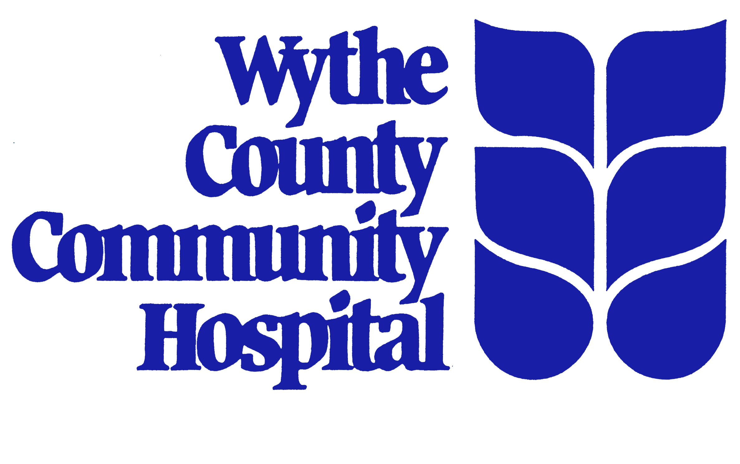
Universal Medication Form
Fold this form and keep it in your wallet Date Form Started:
Name: |  |  | Address:
Phone Number:
Birth Date:
Emergency Contact and Phone Numbers:
IMMUNIZATION RECORD (Record the date/year of last dose taken, if known)
Tetanus | Flu Vaccine(s)
Pneumonia Vaccine | Hepatitis Vaccine |  |  | Other
Allergic to/Describe Reaction: |  | Allergic to/Describe Reaction
LIST ALL MEDICINES YOU ARE CURRENTLY TAKING: Prescription, over-the-counter medications (examples: aspirin, antacids), herbals (examples: ginseng, gingko), and all as needed (example: nitroglycerin).
Date | Name of Medication/Dose | Directions:  Use patient friendly directions.  (Do not use medical abbreviations.) | Date  Stopped | Notes:
Patient:
1. ALWAYS KEEP THIS FORM WITH YOU. Fold it and keep it in your wallet along with your driver's license in case of an emergency.
2. Write down all of the medicines you are taking and list all of your allergies.
3. Take this form to ALL doctor visits, when you go for tests and ALL hospital visits.
4. WRITE DOWN ALL CHANGES MADE TO YOUR MEDICINES on this form. If you stop a medicine, draw a line through it and write the date it was stopped. Ask your Doctor, Nurse, Pharmacist, or family member to help you to keep it up-to-date.
5. In the NOTES column, write the name of the doctor who told you to take the medicine(s) and why you are taking the medicine (Examples: high blood pressure, high blood sugar, high cholesterol).
6. When you are discharged from the hospital, someone will talk with you about WHICH MEDICINES TO TAKE AND WHICH MEDICINES TO STOP TAKING. Changes may be made after a hospital stay and a new form may be filled out for you to take to the doctor with you. This will keep everyone up-to-date on your medicines.
How does this form help you?
1. This form helps you and your family remember all of the medicines you are taking.
2. Your doctor(s) and other healthcare professionals will have a current list of ALL of your medicines including herbals, vitamins, and over-the-counter medicines that you take!
For Copies, visit www.WCCH.org

This form is a free service provided by Wythe County Community Hospital, 600 W. Ridge Road, Wytheville, VA 24382.
NAD-001 Rev. 08/07

